Virtual Workforce Information System

View User Guide – General Practice and Adult Social Care

September 2019
  - Version 1

Document Purpose: Guidance
Document Name: Virtual Workforce Information System View User Guide
Author: VWIS Programme Manager

Target Audience: VWIS Tool Users

Description: This document is an explanation of the views available to VWIS nominated users including the intelligence each can provide and limitations

Cross Reference: VWIS Technical Guidance

Contents

Introduction…………….………………………. | 3
Document Purpose…………….……………… | 4
General Practice Views
Workforce Baseline………………………. | 5
Workforce Trends……………………...… | 6
Demographic Breakdown…………......… | 7
Retirement Forecast………….............…. | 8
Skills for Care Data………….......................... | 9

Contact Details for further information:
Greater Manchester Health and Social Care Partnership
4th Floor, 3 Piccadilly Place
Manchester
M1 3BN
Gm.vwis@nhs.net
The Virtual Workforce Information System
The VWIS tool is a bespoke resource created for and by the Greater Manchester health and social care system, to allow Local Care Organisations to understand the shape and composition of the integrated care workforce. The tool acts as an enabler of workforce planning through the use of a bespoke suite of views in Tableau.
Case for Change
Workforce information is routinely collected using different systems across the health and social care landscape. Organisational workforce reporting takes place in silo without a mechanism to amalgamate the intelligence and make it available to the wider system
The VWIS tool primarily uses three sources of workforce data.
General Practice Workforce (this document)
Data collected by NHS Digital via the National Workforce Reporting System and published quarterly
Community Health Workforce
Data collected by employing trust, stored and recorded via trust-owned ESR (electronic staff record)
Local Authority Workforce*
Data collected by employing local authority, stored and reported via internal HR systems

The VWIS tool amalgamates raw data from these sources and displays as an aggregation in Tableau
*with the exception of adult social care workforce which is reported once a year via the Skills for Care dataset.

Through using the tool, parties to Local Care Organisations will have the ability to:

- View various workforce metrics to understand the composition of the integrated workforce
- Identify areas of concern through visualisation of aggregated data and trends
- Compare demographics across organisations, locality and teams

General Practice and Adult Social Care
The general practice and adult social care VWIS views display publicly available data from NHS Digital (collected via the National Minimum Dataset) and ‘Skills for Care’.

The General Practice National Minimum Dataset
This data set is collected via the National Workforce Reporting System (an online platform) by practices entering their workforce data. This is collated and aggregated by NHS Digital on a quarterly basis and made publicly available 6 weeks after collection.
Further information can be found at https://digital.nhs.uk/data-and-information/areas-of-interest/workforce/

Skills for Care – Adult Social Care Data
Adult social care workforce data is collected on an annual basis by Skills for Care via the National Minimum Dataset-Social Care. It is not mandatory for organisations to submit to the NMDS-SC however providers are incentivised to do so. Data has been collected via the Skills for Care NMDS-SC up to September 2018. In August 2019, the NMDS-SC is being replaced by the Adult Social Care Workforce Data Set. More information can be found here - https://www.skillsforcare.org.uk/NMDS-SC-intelligence/NMDS-SC/Adult-Social-Care-Workforce-Data-Set.aspx

Purpose of this document
This document is intended to:
- Provide guidance on the use of the general practice and adult social care views available through VWIS tool
- Demonstrate a selection of the functionalities available in each view
- To support forecasting and intelligence by providing suggestions on interpretation of the information displayed

This document should be read in conjunction with VWIS Technical Guidance to provide information on accessibility and a general user guide to Tableau. User arrangements such as permission granting are also covered in the technical guidance.

General Practice VWIS Views
Workforce Baseline for GP Practices
Overview
This view provides a baseline of all general practice data across Greater Manchester as recorded by the NMDS.
Filters
Adaptable filters in this view are the following:
Reporting Month – allows the user to select which months’ data to view. Data is pulled from NMDS on a quarterly basis and released via NHSD 6 weeks later.
Display Measure – user can choose to view by Local Care Organisation (borough)/ staff group/ job role/ FTE. To view information for one borough only, click on the borough of interest and “keep only” when it appears in the dialogue box.
Staff Group – the overall staff grouping combined between health and social care
Occupation – a more specific breakdown of job roles

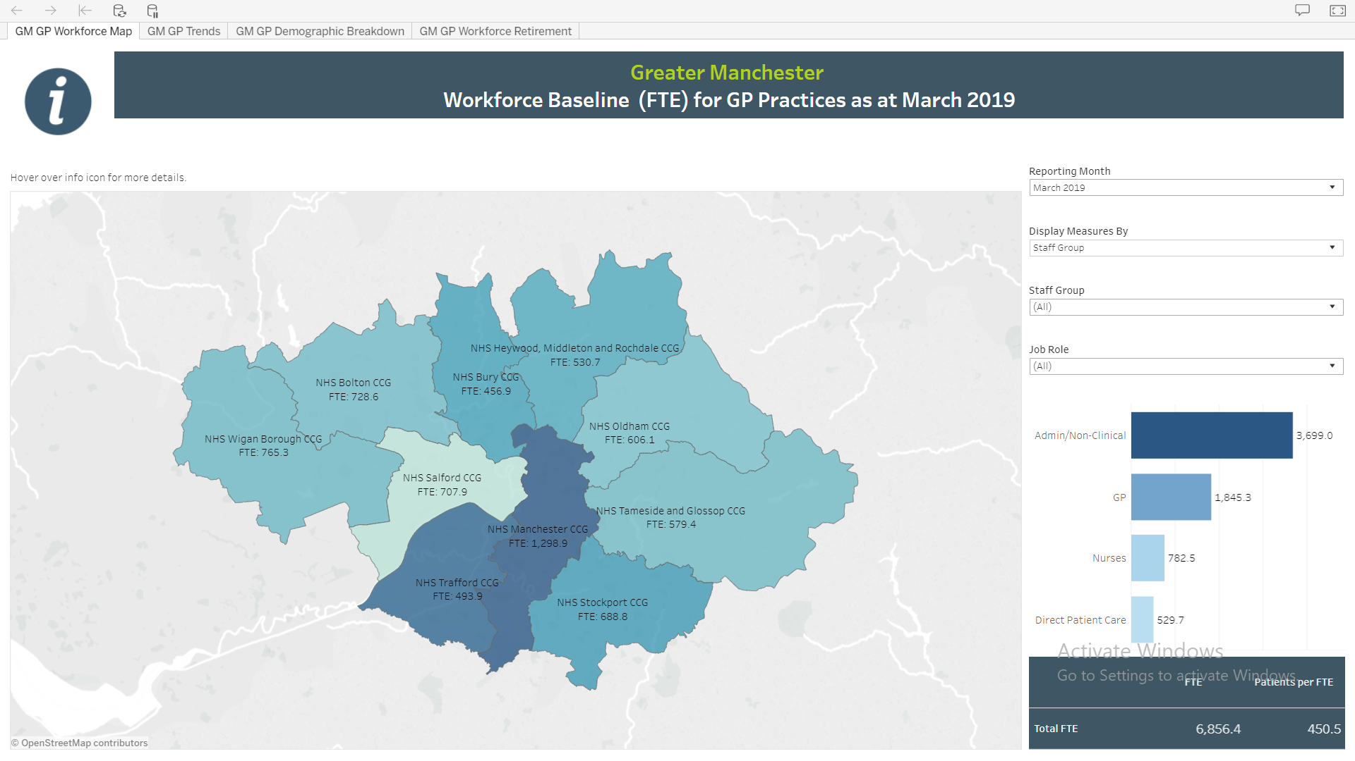

Intelligence provided
This view allows the user to look at the total FTE across job roles within general practice across the whole of Greater Manchester. This view also provides the average age of the selected workforce and the number of patients per FTE. This is particularly useful when filtering by the patient-focused job roles.

Workforce Baseline Trends (FTE) for GP Practices

Overview
This visualisation uses datasets from September 2016 to March 2019 to display the baseline number of FTE staff members across different localities and job roles. In the screenshot below, we have filtered to show all staff working in general practice across all Greater Manchester localities, however it is possible to filter by just locality and particular job roles (e.g. changes to the number of practice nurses in x locality over the past 2.5 years)

Filters
Adaptable filters in this view are the following
Display Measures By – allows the user to select staff group, job role, LCO or total FTE. This will affect how the graph is presented
LCO – user can select which borough to look at specifically
Staff Group/ job role – user can look at a specific staff group and more detailed job role

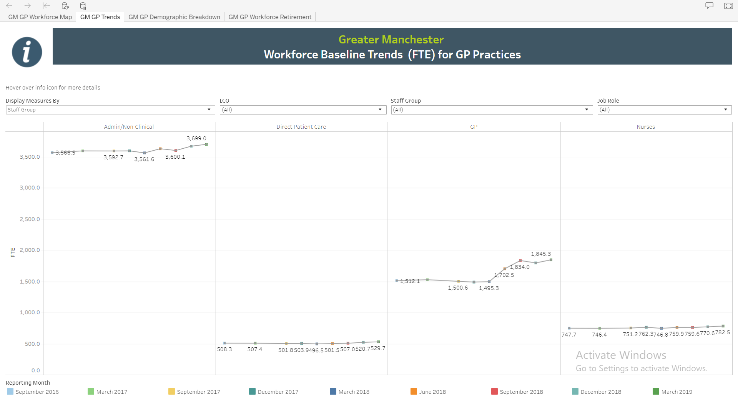

Intelligence Provided
This view allows the user to look at trends over time across specific areas and job roles.

Workforce Demographics (FTE) for GP Practices

Overview
This visualisation demonstrates the general practice workforce of the locality broken down by gender/ age band/ country of qualification. This can be filtered down to job role to give a more granular picture of the composition of the workforce.

Filters
Adaptable filters in this view are the following
DisplayBy – allows the user to pick the presentation of the data in the chart
Reporting month – allows the user to view a specific reporting period and view changes over time
Staff Group/ Job Role – dive down into the categories above within specific staff groups and job roles

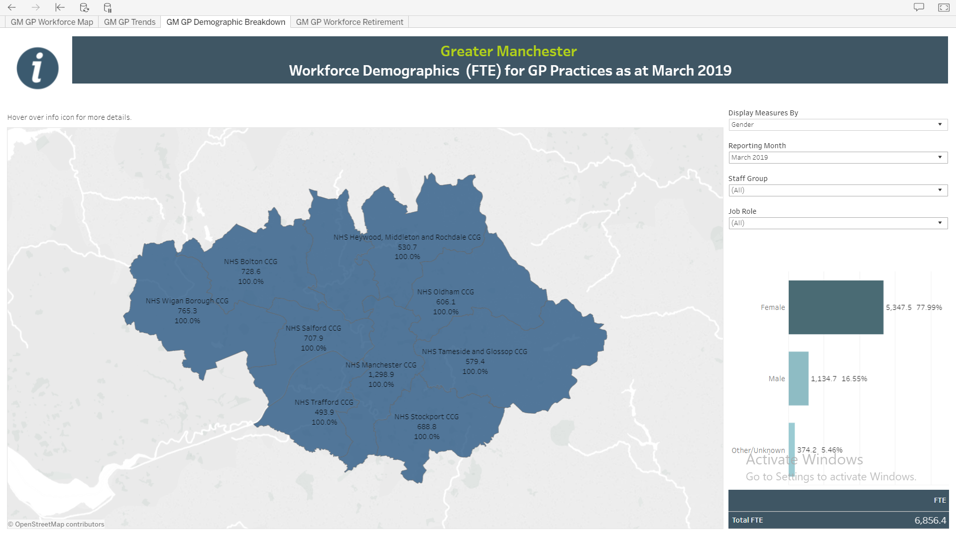

Intelligence Provided
This view allows the user to see the demographic breakdown in the workforce, and can be used to compare to the trends within the local community.

Retirement Forecast for GP Practices

Overview
This visualisation primarily uses age metrics to give a forecast of the numbers of FTE that will fall within a possible retirement age in a given time period. This can be filtered by staff group (GP/ nurse/ direct patient care/ admin) or job role. In the example screenshot below, we are seeing that across the GM ICS, there are 46 nurses that will reach the age of 65 within the next 5 years. This allows strategists and planners to consider future gaps in the workforce due to retirement only (planners will also need to consider population change and growth).

Filters
Adaptable filters in this view are the following:
Retirement Age – free text box to type in any number
Number of years to retirement age – free text box to type in any number
DisplayBy – changes the display within the chart underneath the filters
CountBy – pick FTE or headcount

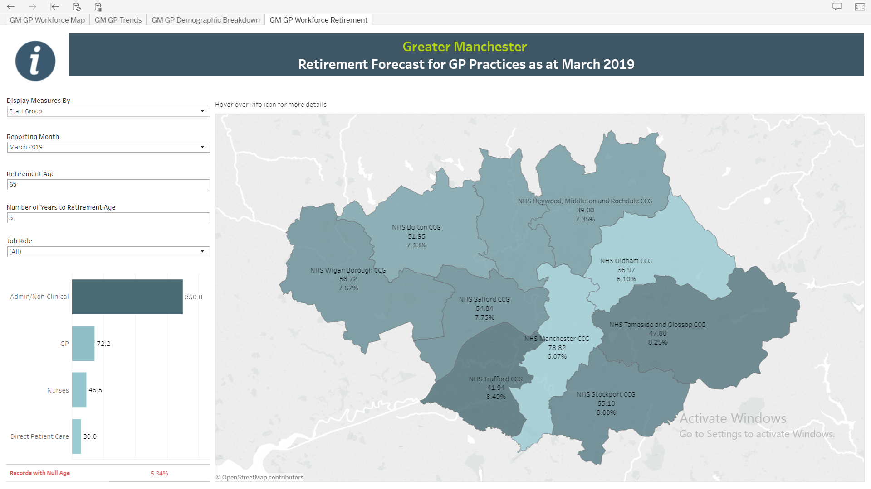

Intelligence Provided
While the intelligence provided by this view is specific, it shows the number of anticipated staff being lost to retirement in any given age. This can then be combined with other sources of data, which demonstrate the new players into the system and allows to predict shortfalls in staffing due to retirement and age only. We know that in some areas we have an aging workforce – this allows us to see where needs to be targeted with intervention and at how far in the future.

Data from the Adult Social Care Dataset

Overview
Skills for Care (www.skillsforcare.org.uk) produce an annual report on the state of the adult social care workforce from residential care homes across the various regions in England. Data is collected from ASC providers and released publicly on an annual basis. The VWIS tool uses this data to provide a high-level overview of the headcount working within residential homes across the Greater Manchester localities.

Filters
Adaptable filters in this view are the following:
Retirement Age – free text box to type in any number
Number of years to retirement age – free text box to type in any number
DisplayBy – changes the display within the chart underneath the filters
CountBy – FTE or headcount

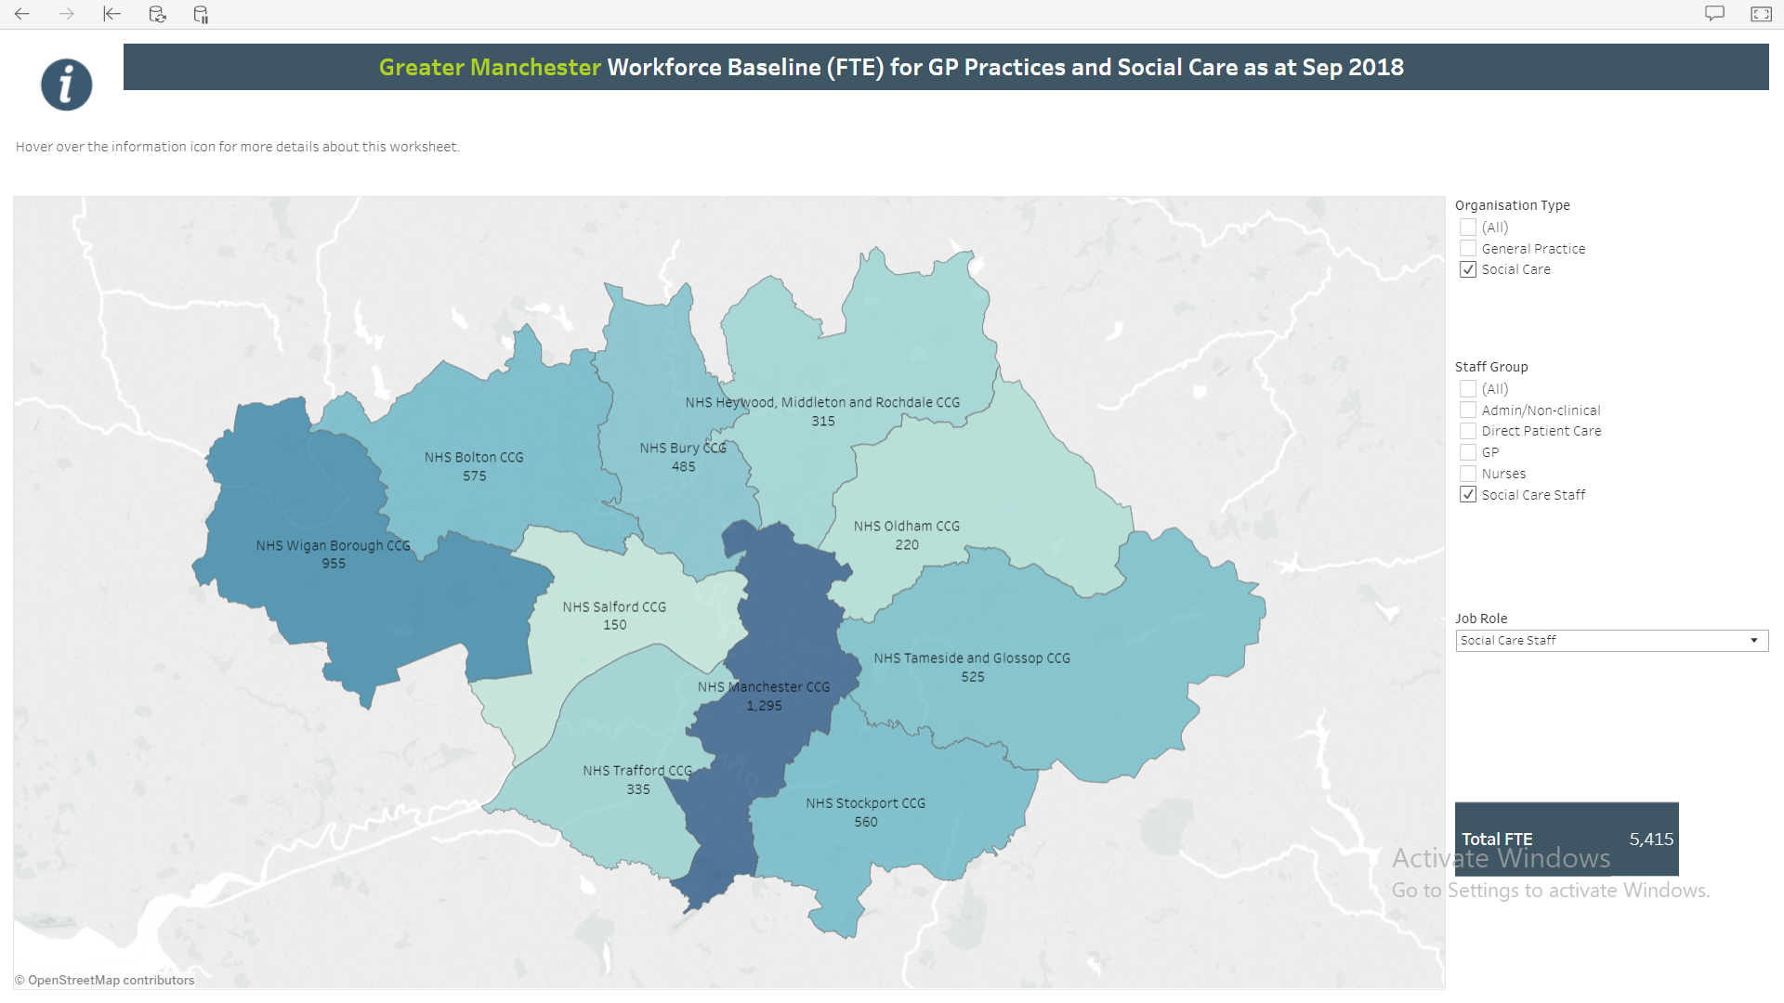

Intelligence Provided
This view provides the numbers of staff employed by the independent sector and working in adult social care in any particular borough.

