Resource 3
Organisational Change

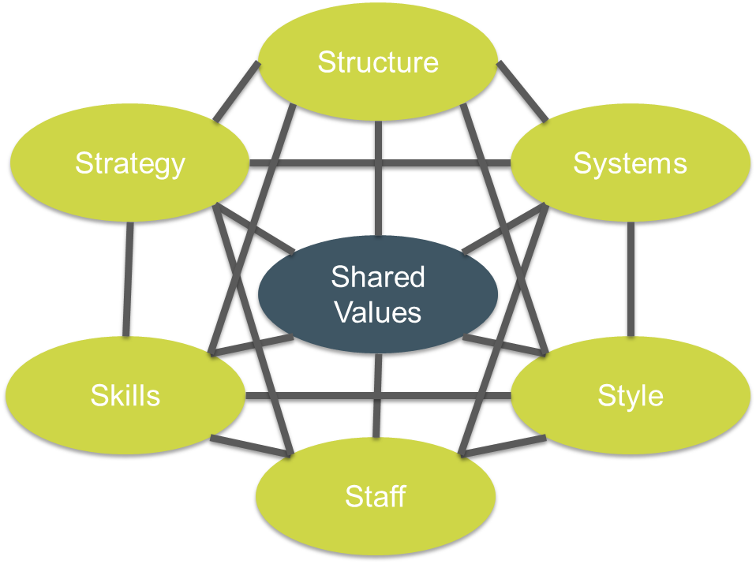
(McKinsey’s 7 S Model of Organisational Change)

Workforce planning is about organisational change and transformation. It is highly unlikely that through developing a workforce plan, you decide that the future workforce needs to be the same as the current workforce. This underlines the need to adopt a change management approach from the beginning of the planning process. The 7 S model can provide a framework for you to consider, and this can support you in identifying your stakeholders too. Below are some questions to consider, related to workforce planning, to support your change management approach.

Strategy:
- What are the key objectives of this workforce planning exercise?
- How are you going to make workforce planning happen?
- What services/populations/communities are you workforce planning for?
- What is the context or strategic landscape you need to consider in your planning process?
Structure:
- How will you “structure” the workforce planning process over time and who will be involved when and how?
- Where and how will the key decisions be made about the future workforce?
- How will you structure communications between stakeholders?
Systems:
- What information and data systems do you need to access to support the workforce planning process?
- What accountability and governance systems do you need to consider to ensure that the implementation of the future workforce configuration happens?
Shared Values:
- How are you going to facilitate and support the partnership working that needs to happen for integrated workforce planning to be successful?
- How will you support stakeholders to identify common purpose and values in relation to the workforce planning process?
Style:
- What facilitation and leadership style will you adopt to gain the most sustainable traction possible in the workforce planning process?
Staff:
- How will you identify, engage, and include relevant stakeholders in the workforce planning process?
Skills:
- What support might you need in terms of specialist or expert knowledge and skills, that are relevant to workforce planning?

Personal Change

Workforce planning stimulates changes related to roles, job profiles and job descriptions, and will inevitably impact directly and indirectly on people, who have to process and respond to what might be personal change related to their own role. Sometimes this can manifest itself in quite specific behaviours, both during the workforce planning process itself (as the potential change becomes apparent), or after the process as you begin the implementation phase. Whichever “academic” change curve you might use to help you understand what people might be experiencing in terms of the raft of emotions, which in turn drive behaviours. For example, if we take the Hopson and Adams change curve, we can identify some of the possible behaviours we might see amongst colleagues as they process any potential change or impact on their role or professional status, that may be a result of an inclusive workforce planning process.
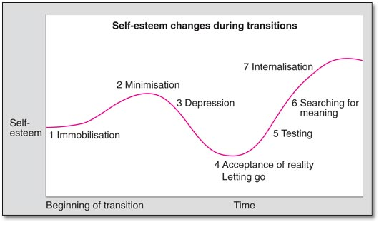

PHASE OF CHANGE | POSSIBLE BEHAVIOURS
Immobilisation | Person may appear to be stuck, inactive, not as engaged, or energetic
Minimisation | Person may display a much happier and more relaxed demeanour than you would expect
Depression | Person may display feelings of sadness or unhappiness, and may at the extreme, engage in negative behaviours to help themselves cope with the anticipated change
Acceptance of reality/letting go | Person may engage more relative to the previous stages and talk more positively about the new context and situation regarding their role
Testing | Person may display more confident behaviour and become proactive at preparing for and making the role/job changes work
Searching for Meaning | Person begins to include their job/role changes into their daily routines and rituals
Internalisation | Person begins to integrate the job/role changes into their everyday identity through visible signs, verbal behaviours and responses

